CHAPTER I
INTRODUCTION
This chapter presents the background of the study, purpose and description of the proposed system, statement of the problem, objectives, significance, and scope and delimitation. It introduces the need for a web-based academic repository that can store documents and check document similarity in a more organized and measurable way.
Project Context
Information technology has changed the way educational institutions manage academic documents and protect academic integrity. Web-based repositories are now used to store research outputs, organize documents, and make academic records easier to access. Plagiarism detection systems also help institutions check the originality of submitted works and support fair academic evaluation.
In many local academic institutions, document submission and plagiarism checking are still partly manual. Students submit research papers and other academic documents, while instructors or administrators check originality using separate tools or manual review. This process may take time and may produce inconsistent results because the documents are not stored and checked in one centralized platform.
Based on observation of the existing process, common problems include slow plagiarism checking, lack of a centralized repository, difficulty in detecting partial similarities, and limited access control. These problems may affect the quality of document management and the protection of academic integrity.
To address these problems, this study proposes an Academic Repository with Plagiarism Detection using TF-IDF and Cosine Similarity. The system is a web-based platform that allows academic documents to be uploaded, stored, analyzed, and monitored in a more organized and secure manner.
Purpose and Description
This study aims to design and develop a web-based academic repository with automated plagiarism detection. The purpose of the system is to improve academic document management and provide a simple way to check document similarity.
The system has three types of users: guest users, registered users, and administrators. Guest users can access limited information. Registered users can upload documents and check similarity results. Administrators can manage user accounts, uploaded documents, and plagiarism reports. The system uses secure authentication and access control to make sure that only authorized users can perform specific actions.
The plagiarism detection feature uses text extraction, TF-IDF, and cosine similarity. After a document is uploaded, the system extracts the text, computes word importance, compares the document with saved documents, and displays the similarity score and matched text.
Statement of the Problem
The current process of managing academic documents and checking plagiarism is still difficult because some tasks are done manually. Documents are not stored in one central place, checking originality takes time, and similar content is difficult to identify. This study seeks to answer the following questions:
1. What problems are encountered in the current process of managing and checking academic documents?
2. How can a web-based repository improve the storage, management, and retrieval of academic documents?
3. How can TF-IDF and cosine similarity be used to detect document similarity and support plagiarism checking?
Objectives
General Objective
The general objective of this study is to design and develop a web-based academic repository with plagiarism detection using TF-IDF and cosine similarity for storing, managing, and checking academic documents.
Specific Objectives
1. To identify the problems in the current academic document management and plagiarism checking process.
2. To develop a centralized web-based repository for academic documents.
3. To allow users to upload, manage, and retrieve PDF, DOCX, and TXT files.
4. To implement text extraction, TF-IDF, and cosine similarity for document similarity checking.

Significance of the Study
This study is significant to students because it gives them a convenient way to upload academic documents and check the originality of their work. The system can help students become more aware of proper academic writing and avoid possible plagiarism.
The study is useful to teachers because it reduces the time needed for manual checking. Through automatic similarity checking, teachers can review submitted documents more efficiently and focus more on evaluating the quality of the content.
The system is also helpful to administrators because it provides a centralized platform for monitoring users, documents, and plagiarism reports. This supports better document organization and strengthens academic integrity in the institution.
Future researchers may use this study as a reference for developing related systems involving document repositories, plagiarism detection, text mining, and similarity analysis. Student developers may also gain knowledge in web development, database design, and algorithm implementation.
Scope and Delimitation
The scope of this study focuses on the development of a web-based academic repository with plagiarism detection. The system allows users to register, log in, upload documents, extract text, check similarity, view results, and generate reports. It supports PDF, DOCX, and TXT file formats. The system uses TF-IDF to represent document terms and cosine similarity to compute similarity scores.
The study is limited to documents uploaded within the system database. It does not check the whole internet and does not use advanced artificial intelligence or deep learning models. The system also does not provide full multilingual plagiarism detection. Its accuracy depends on the quality of extracted text and the available documents stored in the repository.

CHAPTER II
REVIEW OF RELATED LITERATURE
This chapter presents the literature and studies related to academic repositories, plagiarism detection, web-based systems, and document similarity algorithms. These references support the development of the proposed system and show the importance of using digital tools in academic document management.
Academic Digital Repositories
Academic digital repositories are important tools for storing, preserving, and sharing scholarly outputs in educational institutions. Lynch explained that institutional repositories are not only storage systems but also a commitment to access, preservation, and long-term management of academic knowledge. This supports the need for schools to maintain organized and accessible academic records.
Repository systems such as DSpace show how digital platforms can help institutions manage large volumes of academic materials. These systems support proper metadata, document storage, and controlled access. In the proposed system, the repository concept is applied by allowing documents to be uploaded, saved, organized, and retrieved through a web-based platform.
The literature shows that repository systems must be sustainable, organized, and secure. For this reason, the proposed system includes user roles, document metadata, and database storage to support better management of academic documents.
Plagiarism Detection
Plagiarism detection is the process of identifying copied, similar, or closely related content in documents. Different techniques are used in plagiarism detection, including exact matching, document fingerprinting, lexical comparison, and vector-space methods.
Vector-space models are commonly used because they can represent documents as numerical vectors. Salton, Wong, and Yang introduced the vector-space model for automatic indexing, while Sparck Jones introduced term weighting through inverse document frequency. These concepts are important because they serve as the basis for TF-IDF, which is used in the proposed system.
TF-IDF helps identify important words in a document, while cosine similarity measures how close two document vectors are. These algorithms are useful for educational systems because they are explainable, practical, and efficient for comparing uploaded documents.
System Technical Background
The proposed system combines a web-based repository and plagiarism detection algorithm. The frontend provides the user interface for registration, login, file upload, and result viewing. The backend handles document processing, text extraction, TF-IDF computation, cosine similarity checking, and report generation.
The system stores users, documents, extracted text, and similarity results in a database. Role-based access control is used to separate the functions of guest users, registered users, and administrators. This improves security and makes the system more organized.
Security is also important in this system. Authentication, upload restrictions, and protected routes help prevent unauthorized access. These features support the safe use of the system in an academic environment.
Synthesis and Research Gap
The reviewed literature shows that academic repositories and plagiarism detection systems are useful in improving document management and academic integrity. Repositories help preserve documents, while plagiarism detection systems help check originality and similarity.
However, some existing systems focus only on document storage, while others focus only on plagiarism checking. This creates a gap for a system that combines repository management and algorithm-based similarity checking in one platform.
The proposed study addresses this gap by developing a web-based academic repository with plagiarism detection using TF-IDF and cosine similarity. It provides document upload, text extraction, similarity scoring, report viewing, and role-based access in a single system.

CHAPTER III
METHODS
This chapter presents the methods used in the development of the Academic Repository with Plagiarism Detection. It includes the development model, data gathering process, requirements analysis, system design, algorithms, implementation, and testing procedure.
Model / SDLC
The system uses the Agile Software Development Life Cycle (SDLC) model. Agile was selected because it allows the proponents to develop the system step by step and improve the system based on testing and feedback. Each module is designed, developed, tested, and improved before moving to the next feature.
The Agile model is suitable for this study because the system includes several modules such as user registration, login, document upload, text extraction, plagiarism checking, result viewing, and admin management. These modules can be developed and tested in small parts.
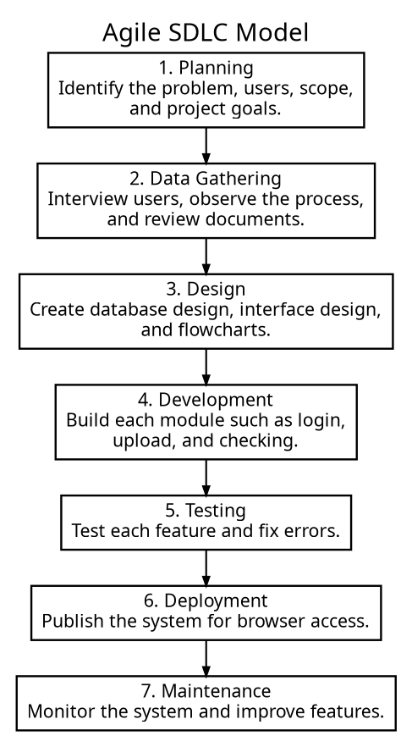
Figure 1. Agile SDLC Model
Figure 1 shows the Agile SDLC model used in the development of the system. It presents the process from planning, data gathering, design, development, testing, deployment, and maintenance.
Data Gathering
Data gathering was conducted to understand the existing process of academic document submission and plagiarism checking. The proponents used interviews, observation, and document review to identify the problems and system requirements.
Interviews were conducted with students and teachers to know how academic documents are submitted, stored, and checked. The responses helped identify the need for a faster and more organized system.
Observation was also done to understand the current manual process. The proponents observed that document submission and checking can be time-consuming when there is no central repository.
Document review was used to examine sample academic files and existing forms or records. This helped the proponents identify the needed data fields, file types, and reports for the proposed system.
Requirements Analysis
After gathering information, the proponents analyzed the needs of the users and the problems in the existing process. The main problems identified were the lack of a centralized document repository, slow plagiarism checking, difficulty in comparing documents, and limited monitoring of academic submissions.
The functional requirements describe what the system must do. These include user registration, login, document upload, text extraction, similarity checking, result display, and admin management. The non-functional requirements describe how the system should perform. These include security, usability, reliability, speed, and accessibility through a web browser.
Requirements Documentation
The requirements documentation presents the functional and non-functional requirements of the system. These requirements serve as a guide for the development and testing of the proposed system.
Table 1. Functional Requirements
Req. ID | Requirement Description | Priority
FR-01 | The system shall allow users to register an account. | High
FR-02 | The system shall allow users to log in securely. | High
FR-03 | The system shall allow users to upload PDF, DOCX, and TXT documents. | High
FR-04 | The system shall extract text from uploaded documents. | High
FR-05 | The system shall compute TF-IDF values from extracted text. | High
FR-06 | The system shall compare documents using cosine similarity. | High
FR-07 | The system shall display similarity score and matched text. | High
FR-08 | The system shall allow administrators to manage users, documents, and reports. | High

Table 2. Non-Functional Requirements
Req. ID | Requirement Description | Priority
NFR-01 | The system shall be easy to understand and use. | High
NFR-02 | The system shall protect user accounts and uploaded documents. | High
NFR-03 | The system shall be accessible through modern web browsers. | High
NFR-04 | The system shall process documents within a reasonable time. | Medium
NFR-05 | The system shall store and retrieve records reliably. | High
NFR-06 | The system shall be maintainable for future improvements. | Medium

Design of Software, Systems, Product, and/or Processes
This section presents the design of the proposed Academic Repository with Plagiarism Detection. It includes the conceptual framework, system components, system process flow, and user interface process.
Conceptual Framework
The conceptual framework follows the Input-Process-Output (IPO) model. The input includes user credentials and uploaded documents. The process includes text extraction, TF-IDF computation, cosine similarity checking, and report generation. The output includes similarity score, matched text, plagiarism report, and stored document records.
Table 3. IPO Conceptual Framework of the System
Input | Process | Output
User account details | Register and authenticate users | Verified user access
Uploaded PDF, DOCX, or TXT file | Extract and clean text | Readable document text
Extracted text | Apply TF-IDF and cosine similarity | Similarity score and matched text
Similarity results | Save and display report | Plagiarism report and document record

Detailed Design
The system is designed with three main layers: presentation layer, application layer, and data layer. These layers work together to provide the complete function of the system.
The presentation layer contains the web pages used by the users and administrators. The application layer contains the backend logic for validation, document processing, TF-IDF computation, and cosine similarity checking. The data layer stores user accounts, documents, extracted text, and plagiarism results.
Table 4. System Components
Component | Description
Frontend | Displays the web pages used by guest users, registered users, and administrators.
Backend | Handles file upload, text extraction, TF-IDF computation, cosine similarity, and API requests.
Database | Stores user accounts, documents, extracted text, and similarity reports.
Authentication | Protects user access through secure login and role-based permissions.

System Process Flowchart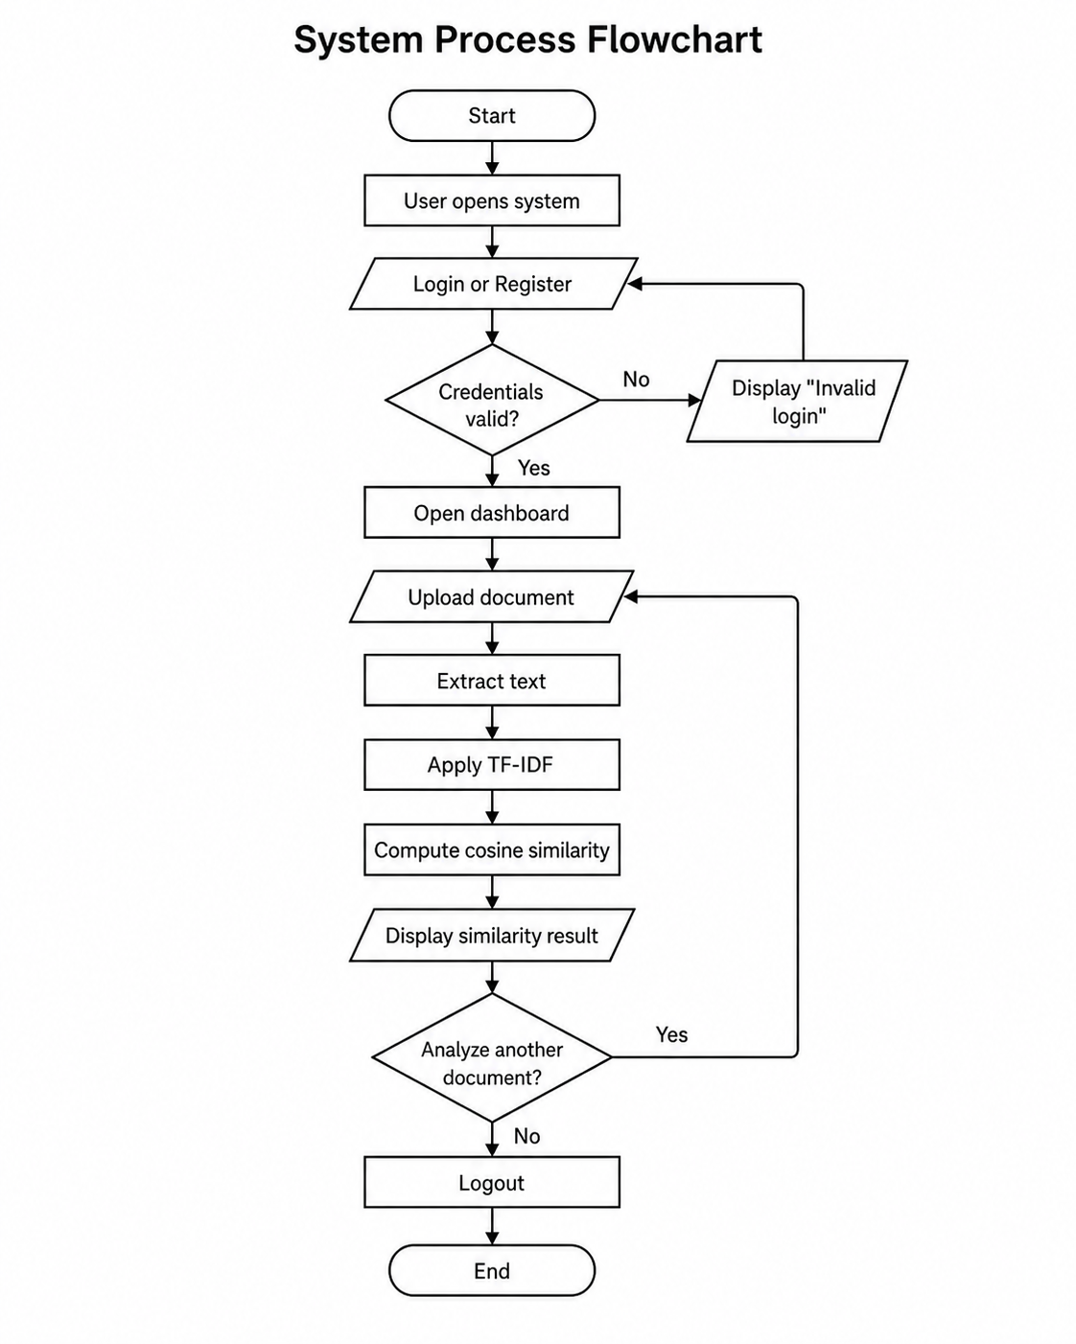
Figure 2. System Process Flowchart
Figure 2 shows the overall system process from user registration or login up to document upload, text extraction, plagiarism checking, result display, and logout.

Algorithms
The system uses text extraction, TF-IDF, and cosine similarity algorithms. These algorithms allow the system to read document content, identify important words, and compute the similarity between documents.
Text Extraction Algorithm
Text extraction is the process of getting readable text from an uploaded document. When the user uploads a file, the system checks the file type. If the file is valid, the system reads the document, extracts the text, cleans the text, and saves it in the database for plagiarism checking.
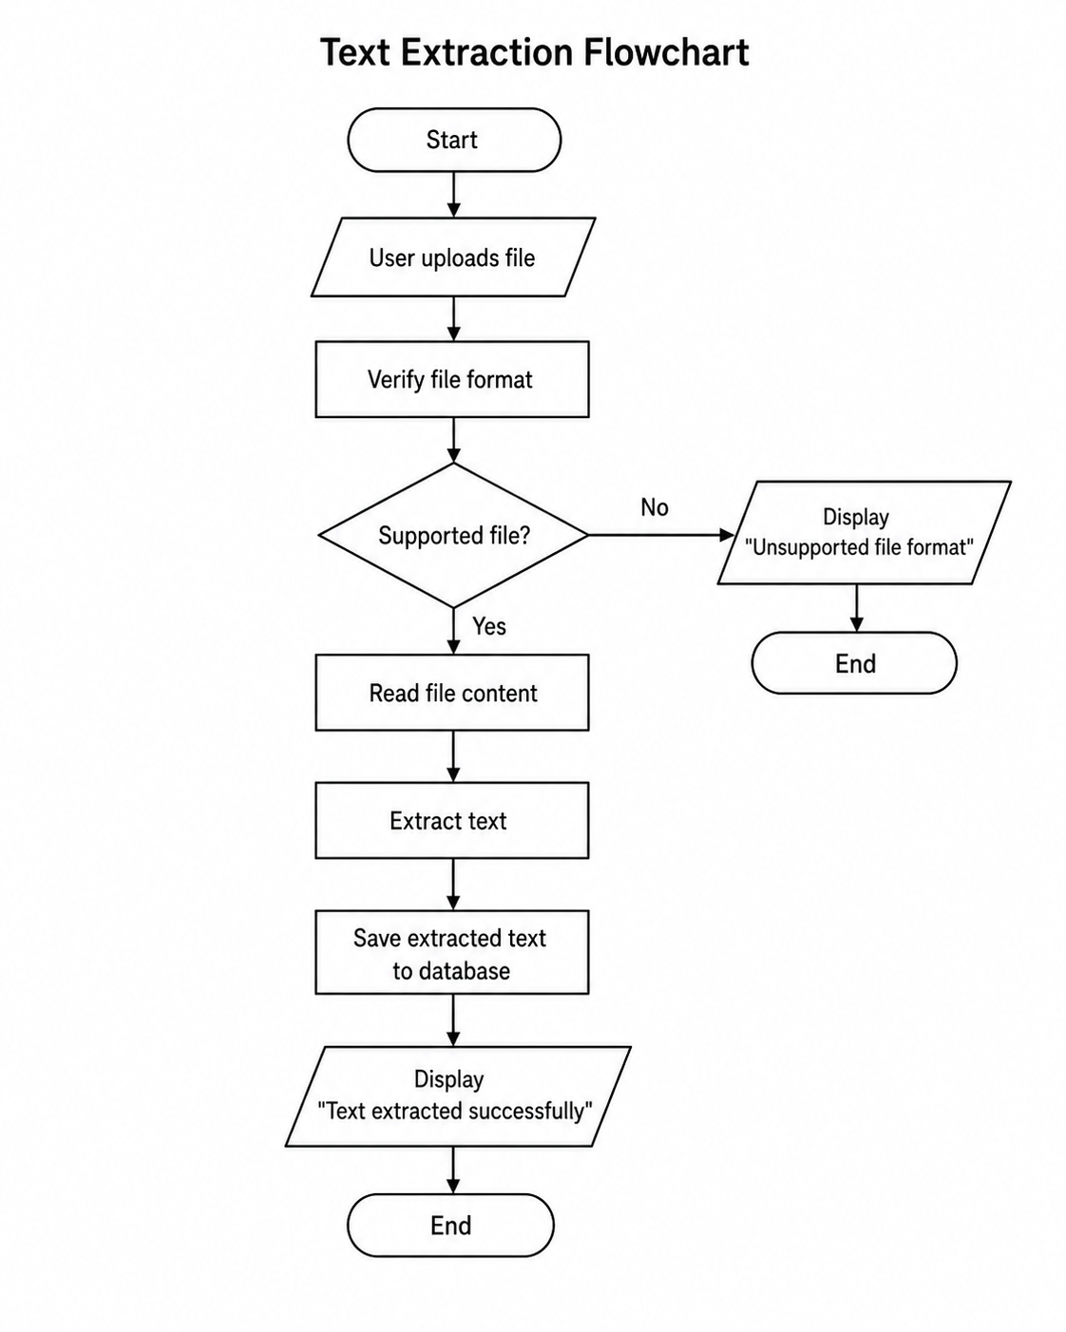
Figure 3. Text Extraction Flowchart
TF-IDF Algorithm
TF-IDF means Term Frequency-Inverse Document Frequency. It is used to determine the importance of a word in a document. Common words receive lower values, while important or rare words receive higher values. The formula is:
TF-IDF = TF x IDF
TF refers to how often a word appears in a document. IDF refers to how important or rare the word is across all documents. The system uses the TF-IDF result to create a document vector for comparison.
Cosine Similarity Algorithm
Cosine similarity measures how similar two documents are based on their TF-IDF vectors. The result ranges from 0 to 1. A score closer to 0 means the documents are less similar, while a score closer to 1 means the documents are more similar.
Cosine Similarity = (A · B) / (|A| x |B|)
In this system, the uploaded document is compared with the documents stored in the database. The system calculates the similarity score and displays the matched content to the user.

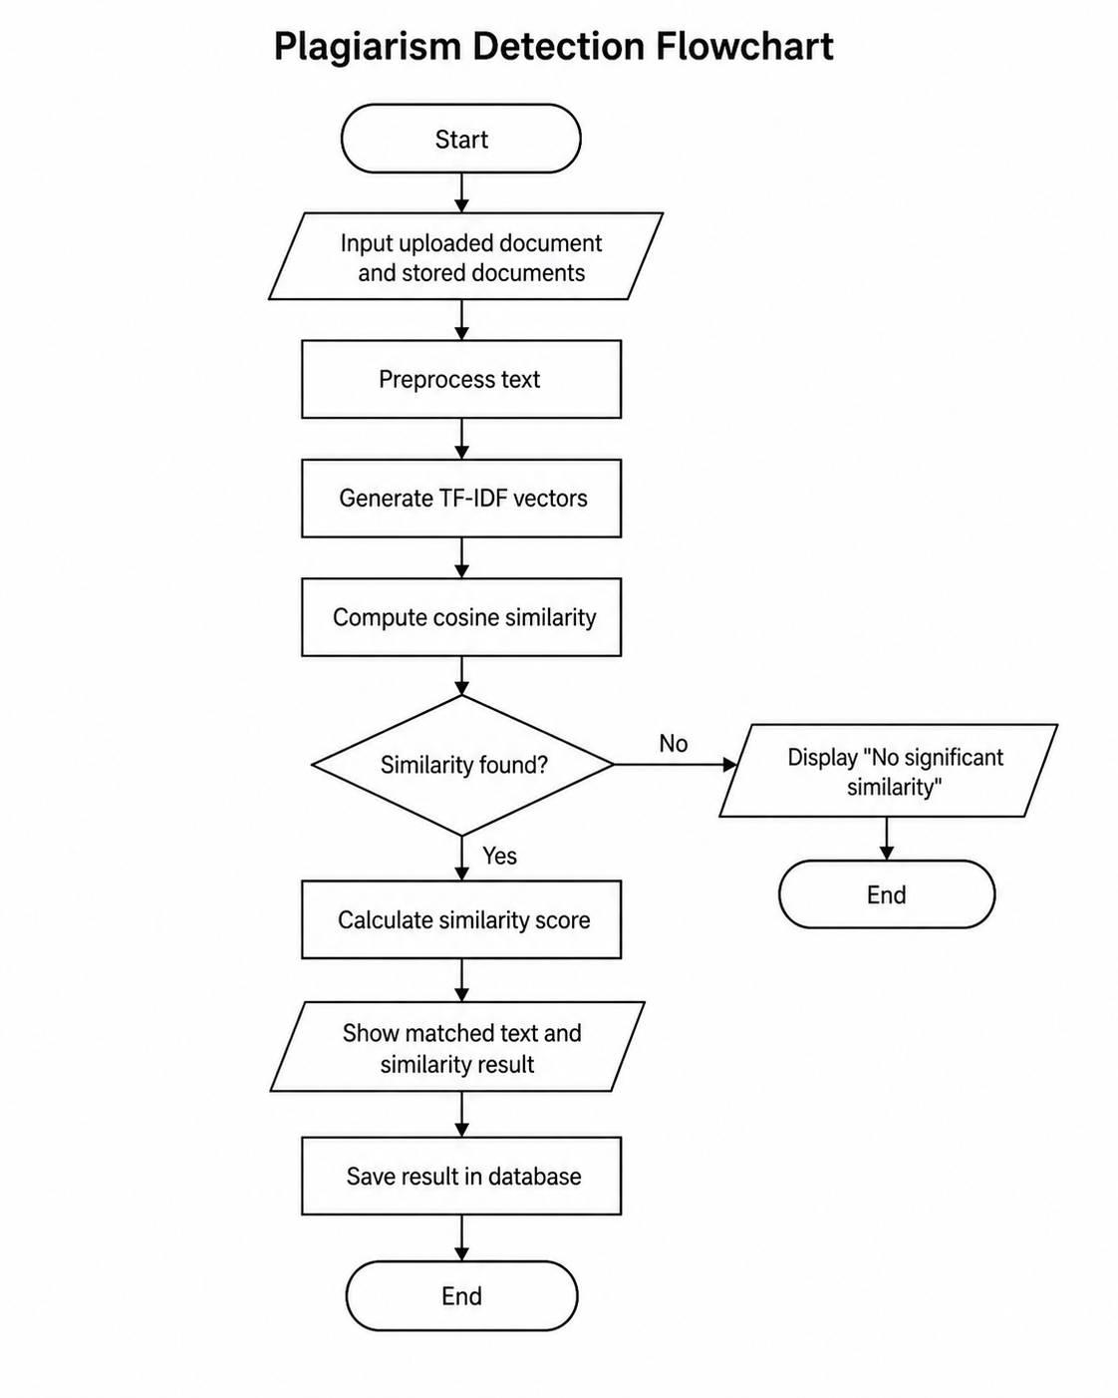
Figure 4. Plagiarism Detection Algorithm Flowchart

User Interface Design

The design of the user interface displays the real screens of the Academic Repository and Plagiarism Detection System. These screenshots demonstrate the way the users interact with the system, such as the login page, dashboard, document upload page, similarity checking page and the admin dashboard. The interface was made to be simple, clear and easy to use.

Software Requirements and Development
The following software tools are used to develop and run the proposed system.
Table 5. Software Requirements
Software / Tool | Purpose
HTML5 | Used for creating the structure of web pages.
CSS3 | Used for designing the system interface.
JavaScript | Used for client-side functions and interaction.
Node.js / Backend API | Used for server-side document processing and system logic.
Supabase / Database | Used for storing users, documents, extracted text, and results.
Visual Studio Code | Used as the code editor during development.
Web Browser | Used to access and test the web application.

Implementation
The system is implemented as a web-based application that can be accessed through a browser. Users can register, log in, upload documents, and view plagiarism checking results.
When a document is uploaded, the system extracts the text and stores it in the database. The system then applies TF-IDF to represent the document and uses cosine similarity to compare it with other saved documents.
The administrator module allows the admin to view users, uploaded documents, and similarity results. This helps the institution manage academic documents in one centralized system.
Testing and Validation
Testing was conducted to check if the system functions work correctly. Each major feature was tested using input and expected output. The testing helped determine whether the system meets the identified requirements.
Table 6. Testing and Validation Results
Test Case | Expected Result | Actual Result | Status
User Registration | User can create an account. | Account created successfully. | Passed
Login | User can log in using valid credentials. | User logged in successfully. | Passed
Upload Document | User can upload a valid file. | File uploaded successfully. | Passed
Text Extraction | System extracts text from the file. | Text extracted successfully. | Passed
Similarity Checking | System computes and displays similarity result. | Result displayed correctly. | Passed
Admin Dashboard | Admin can view users, documents, and reports. | Records displayed successfully. | Passed
Logout | User can exit the system. | User logged out successfully. | Passed

Based on the testing results, the system meets the main requirements of the study. It can store documents, extract text, compute similarity, display results, and support administrator monitoring. The system also improves the existing process by centralizing academic documents and making plagiarism checking faster and easier.

REFERENCES

Alzahrani, S. M., Salim, N., & Abraham, A. Understanding plagiarism linguistic patterns, textual features, and detection methods. IEEE Transactions on Systems, Man, and Cybernetics, Part C (Applications and Reviews), 42(2), 133-149. https://doi.org/10.1109/TSMCC.2011.2134847
Cao, L., & Ramesh, B. Agile requirements engineering practices: An empirical study. IEEE Software, 25(1), 60-67. https://doi.org/10.1109/MS.2008.1
Eisa, T. A. E., Salim, N., & Alzahrani, S. Existing plagiarism detection techniques: A systematic mapping of the scholarly literature. Online Information Review, 39(3), 383-400. https://doi.org/10.1108/OIR-12-2014-0315
Fielding, R. T., & Taylor, R. N. Principled design of the modern Web architecture. Proceedings of the International Conference on Software Engineering, 407-416. https://doi.org/10.1145/337180.337228
Jones, M., Bradley, J., & Sakimura, N. JSON Web Token (JWT) (RFC 7519). IETF. https://doi.org/10.17487/RFC7519
Lynch, C. A. Institutional repositories: Essential infrastructure for scholarship in the digital age. ARL Bimonthly Report, 226. https://www.arl.org/newsltr/226/ir/
Manning, C. D., Raghavan, P., & Schutze, H. Introduction to Information Retrieval. Cambridge University Press. https://doi.org/10.1017/CBO9780511809071
Salton, G., Wong, A., & Yang, C. S. A vector space model for automatic indexing. Communications of the ACM, 18(11), 613-620. https://doi.org/10.1145/361219.361220
Sandhu, R. S., Coyne, E. J., Feinstein, H. L., & Youman, C. E. Role-based access control models. Computer, 29(2), 38-47. https://doi.org/10.1109/2.485845
Schleimer, S., Wilkerson, D. S., & Aiken, A. Winnowing: Local algorithms for document fingerprinting. Proceedings of the ACM SIGMOD International Conference on Management of Data, 76-85. https://doi.org/10.1145/872757.872770
Smith, M., Barton, M., Branschofsky, M., McClellan, G., Walker, J. H., Bass, M., Stuve, D., & Tansley, R. DSpace: An open source dynamic digital repository. D-Lib Magazine, 9(1). https://doi.org/10.1045/january2003-smith
Sparck Jones, K. A statistical interpretation of term specificity and its application in retrieval. Journal of Documentation, 28(1), 11-21. https://doi.org/10.1108/eb026526
Van de Sompel, H., Lagoze, C., Nelson, M., & Warner, S. The Open Archives Initiative Protocol for Metadata Harvesting (Version 2.0). Open Archives Initiative. https://www.openarchives.org/OAI/2.0/openarchivesprotocol.htm

